PowerPoint Questionnaire
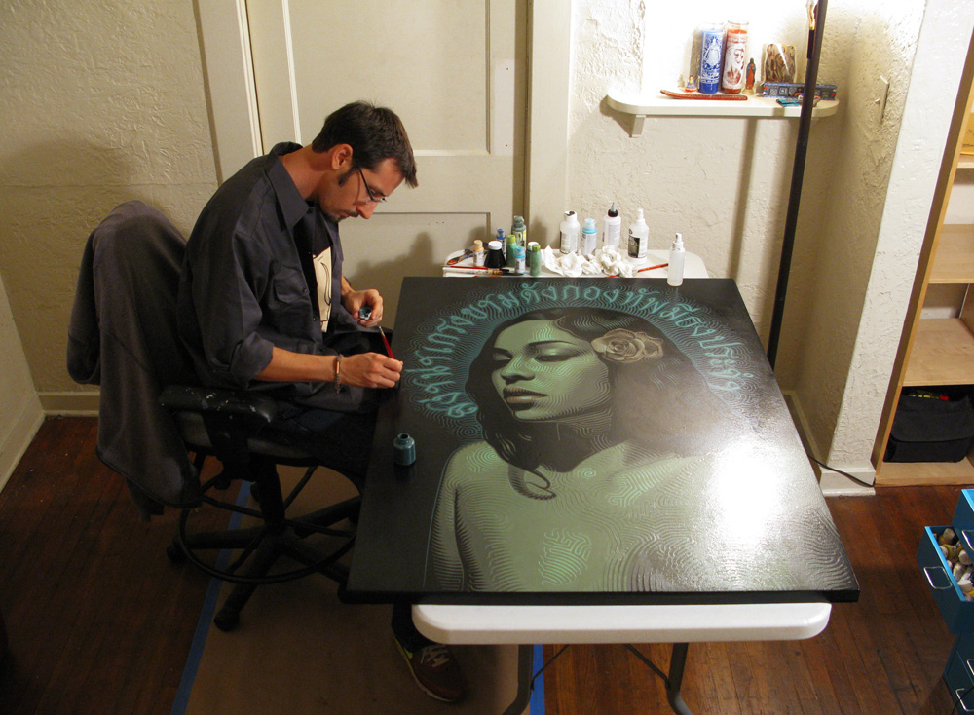

El mac is a ______________ Artists who was born in Los Angeles. El Mac’s work is mixed with more contemporary influence of ___________ and ___________________, and influence by ________ and ________ culture is written all throughout his creation. El Mac began painting with ________ and painting _______ in the mid 90’s when his primary focus became the life-rendering of human _______ and _________. El Mac has developed his unique style, which utilizes ___________________ reminiscent of _______ or _________. Some of El Mac’s murals have become local landmarks, especially with his collaboration with local artist _________. Which combines Mac’s representational figures and Retna’s _________ and ________.

