Activity  Brain Storm your Stencil Design  [Street Address]  [City, ST ZIP Code] |  |  | How to create your very own stencil  By Ivan Huertero

Materials you will need  - A cardboard Pieces  - A razor blade rather than scissors will be explained further  - Pencil, eraser and a little notebook  - Ruler  - Printer  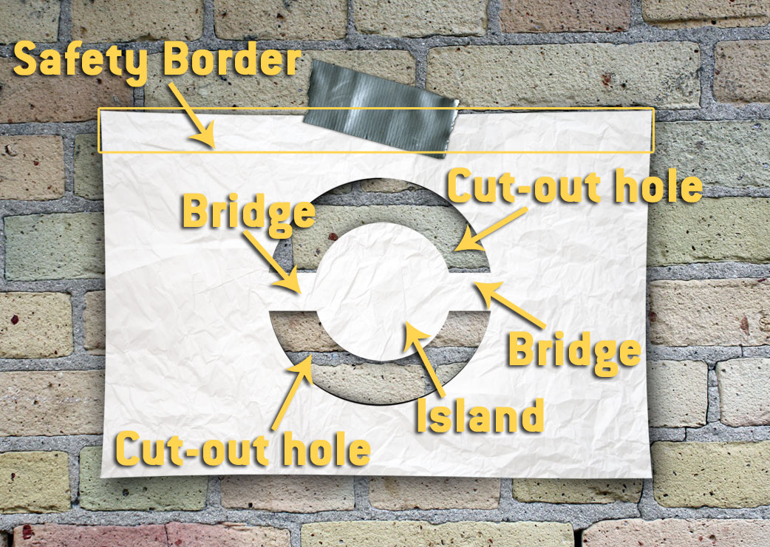 |  |  | Placing the stencil:  Now for some instruction on placing the stencil: you can't just grab it with your fingers and try to fill thru the holes, this way you will only get some really blurred shapes, even If you spray correctly.  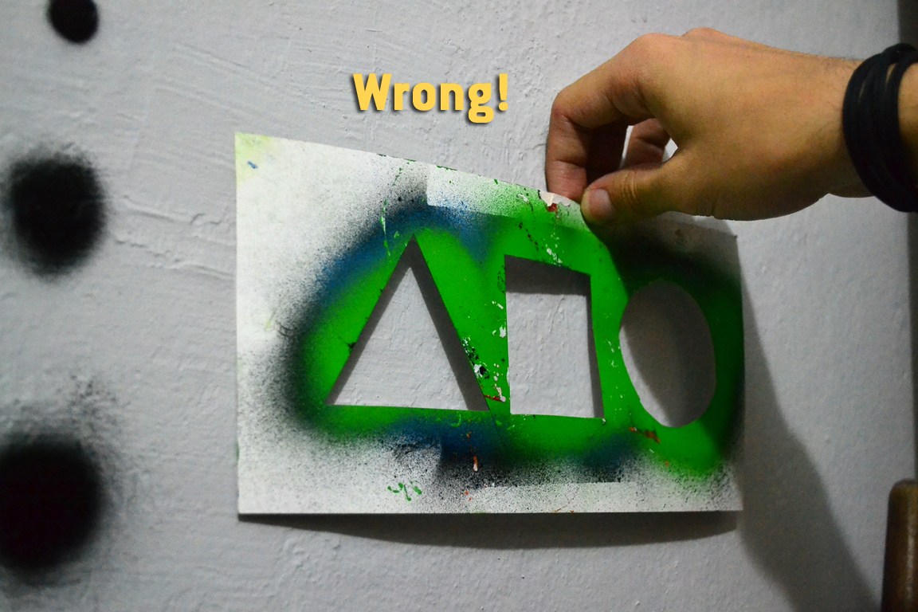  You should stretch and push it against the wall, try to minimize at maximum the space between the stencil and the wall.  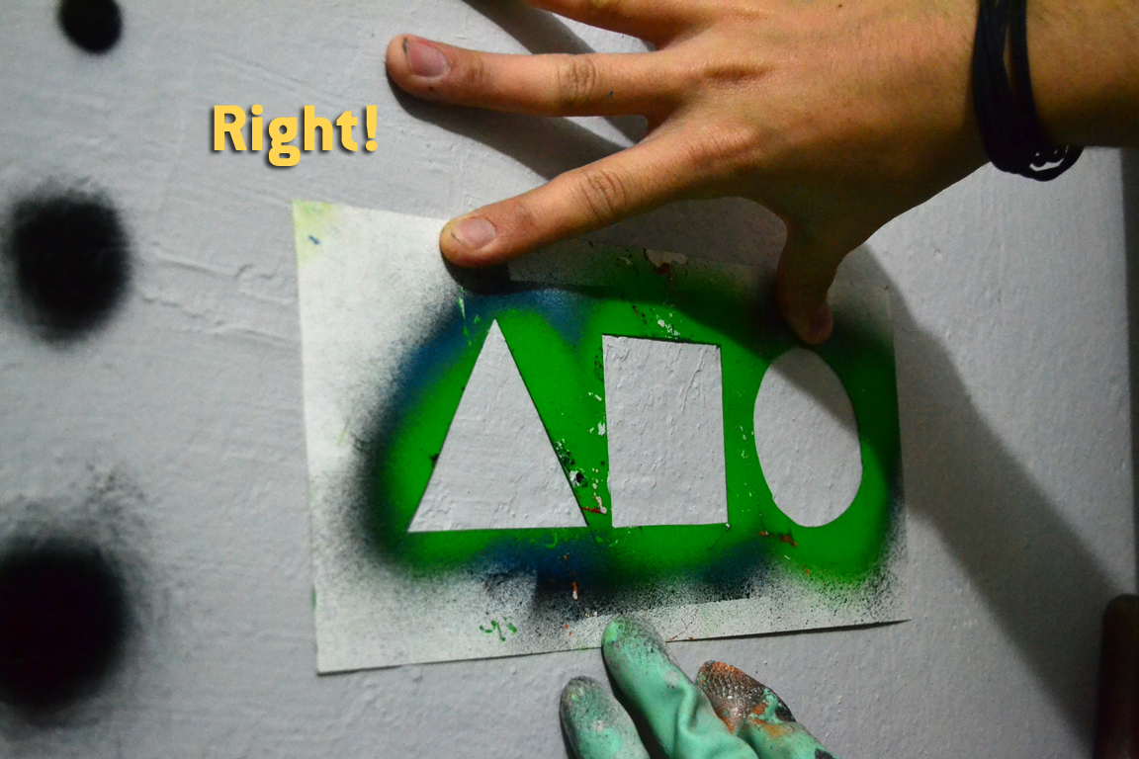
2 |  |  | 7

Making Letters  The same logic goes for making letters, you can make more solid and square shapes in the beginning like the sample bellow:  With time and patient, you will understand how to apply the bridge/island technique on the letters too, it's like rendering but on paper.  Focus on What You Do Best  If you’re using this booklet for a company brochure, these middle pages are a good place for a summary of competitive benefits or some of those glowing testimonials, like the one above.  You might also want to mention a few of your most impressive clients here:  - Big, important company  - Really well-known company  - Very impressive company  Additionally, you could include a bulleted list of products, services, or major benefits of working with your company. Or just summarize your finer points in a few concise paragraphs. |  |  | Understanding Parts of the Stencil  Safety border  I call it safety boarder because it’s the minimum distance you should have from the cut-out hole and the border, this is not specific in terms of measure, it’s more about a distance you should calculate in order to avoid any leak outside of the cut-out hole.  Island/Bridge  The island are the independent parts inside of a cut-out hole, as you may notice shapes can’t float, so that’s why they need bridges.  Bridges are the ligatures that make the island possible to exist on the cut-out hole, knowing where to make this connection may seem a bit hard at the beginning  Cut-out Holes  This is the place where we place the pigment, it should be stretched and pushed hard against the wall or surface to avoid leaks and blurs.
6 |  |  | 3

How to make a Basic stencil  Let's start by designing some simple and solid shapes. I decided to make some sketches of the basic shapes (triangle, square and ellipse). Notice that I did solid shapes, only silhouettes, this might be boring, but before you get the practice of making cut-out holes, you will rather do this kind of stencil. Let's say this is "Level 1".  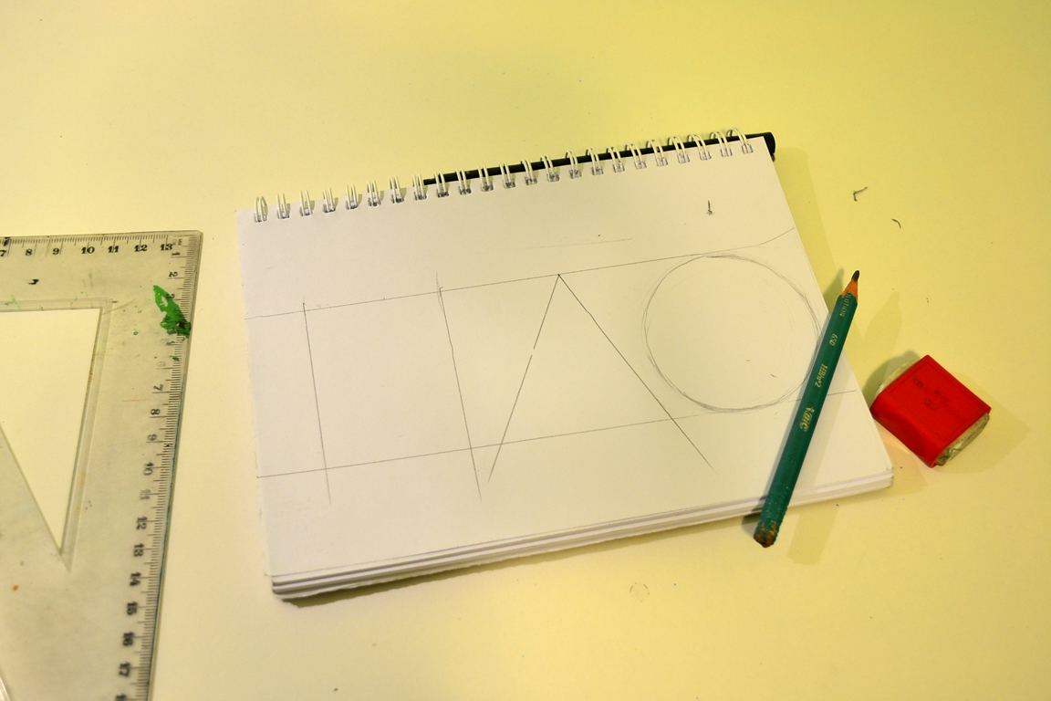  Now with your razor and a ruler, make the cut-out holes on the shapes you designed. Try not to use a scissor, as they are not precise for this kind of work and you probably may have to cut outside the design. |  |  | 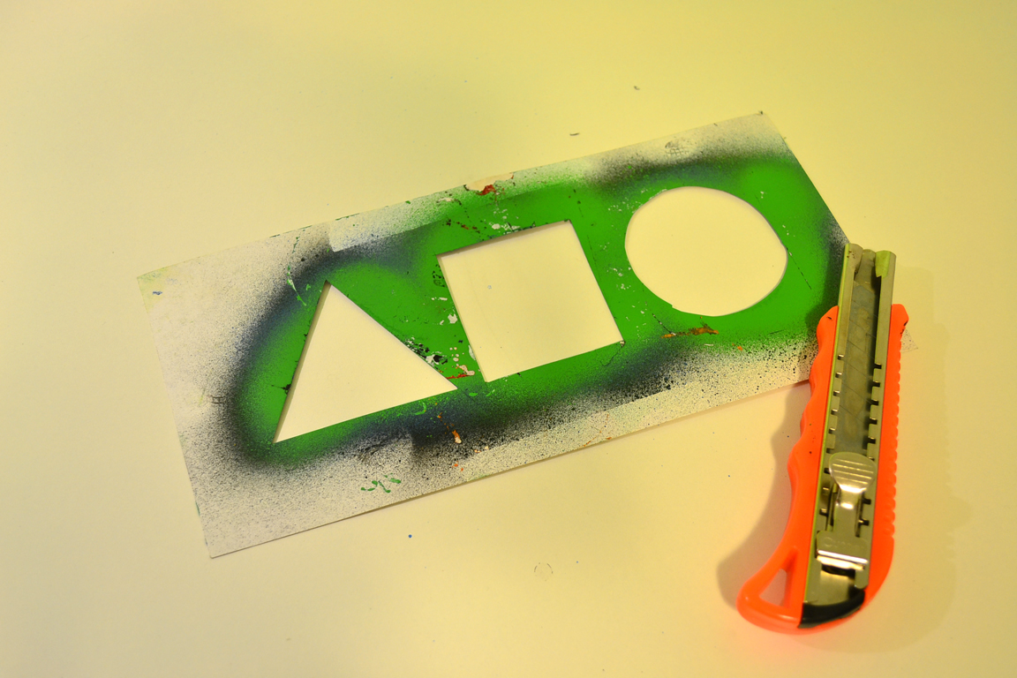  How to make lines using stencils:  Level 2  So, do you remember the stencil parts I explained before? More specifically the bridge and the islands, this will be necessary in order to create more complex shapes.  As you probably notice, in order to make the line just transform the inside of the shapes in big islands, this can vary depending on the size of the outline you want to get.
4 |  |  | 5

